**Create Subnet**

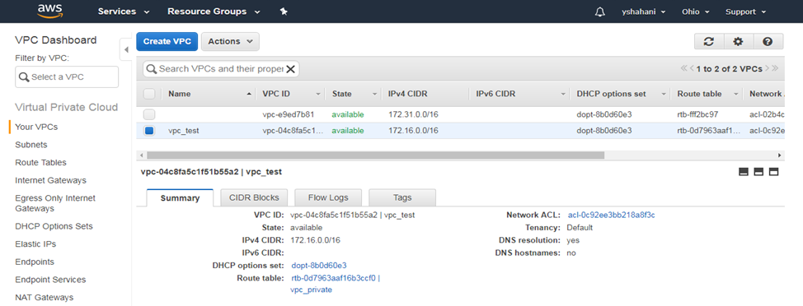

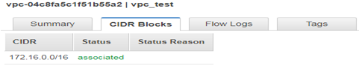

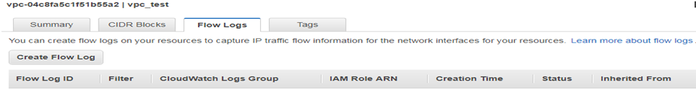

**Subnets**

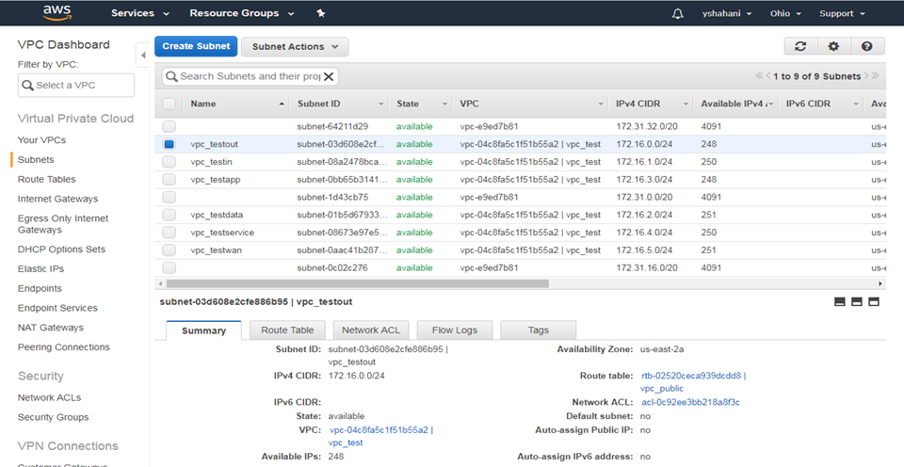

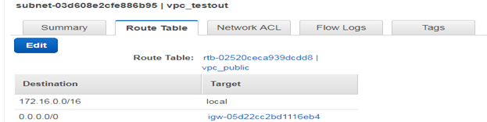

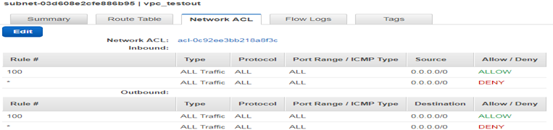

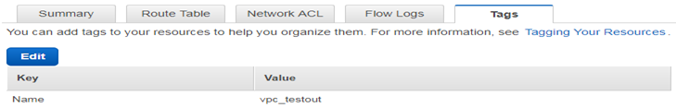

**Route tables**

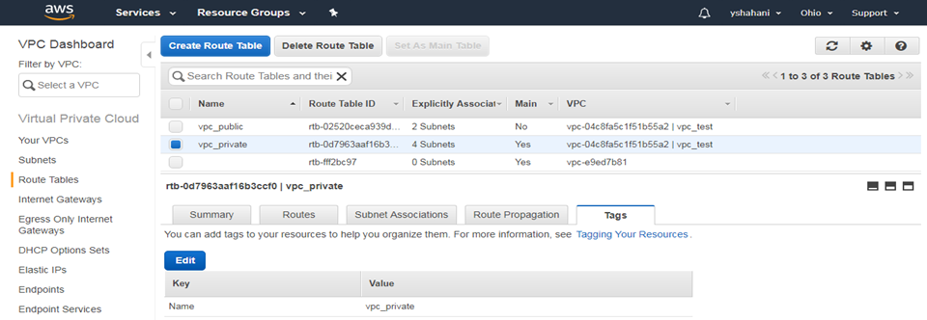

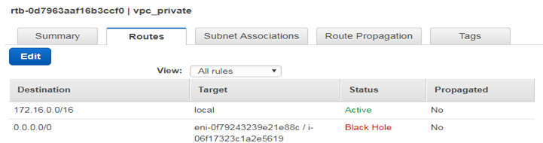

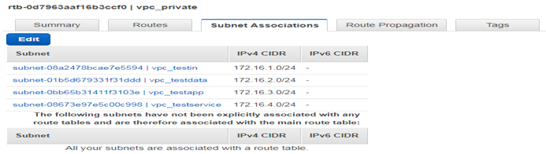

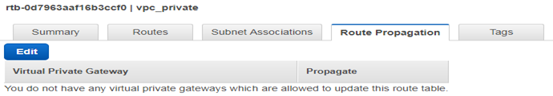

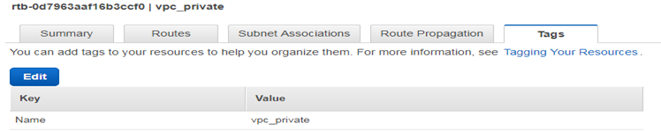

**Internet Gateway**

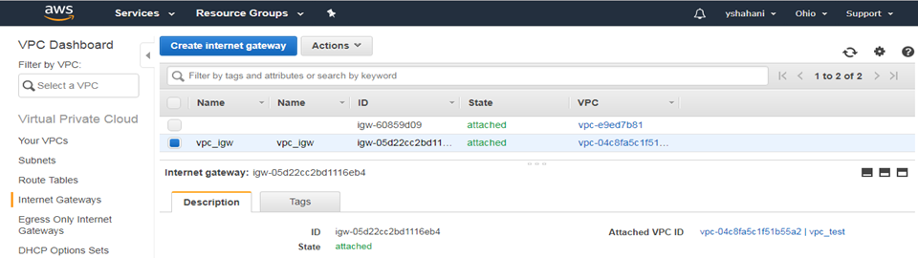

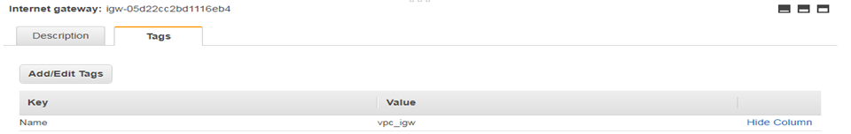

**DHCP options**

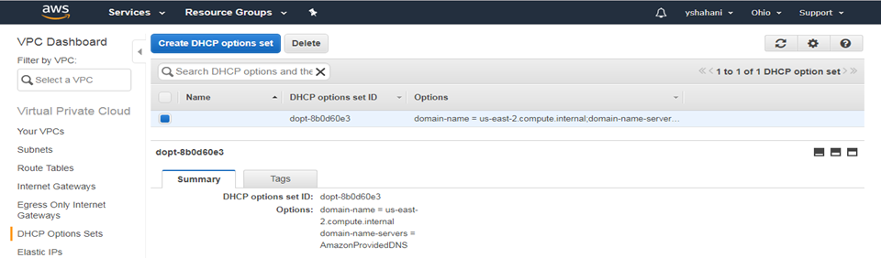

**Elastic Ips**

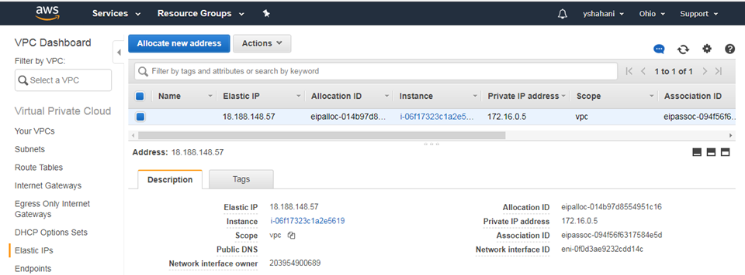

**Security Network ACL’s**

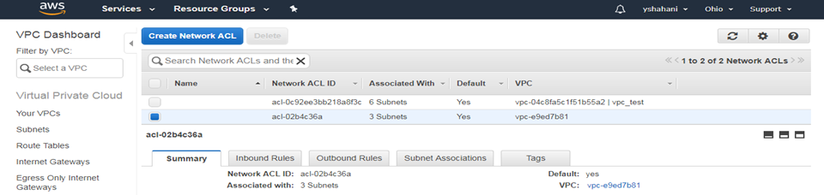

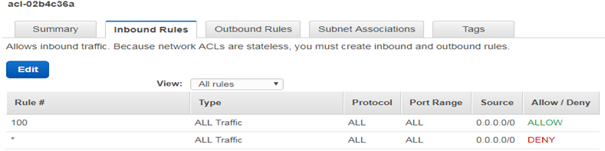

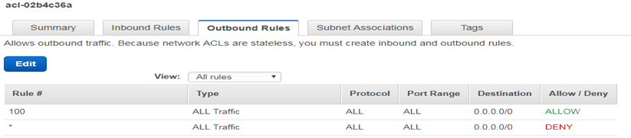

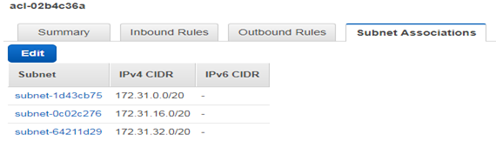

**Security Groups**

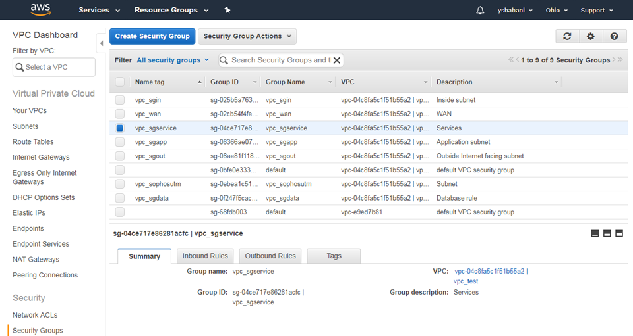

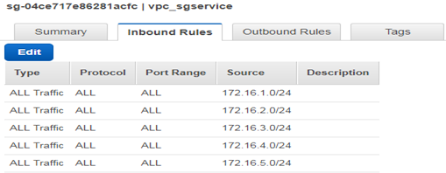

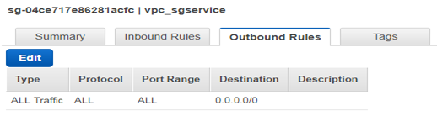

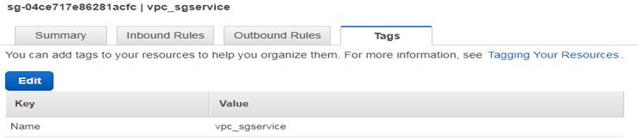

**EC2 management console**

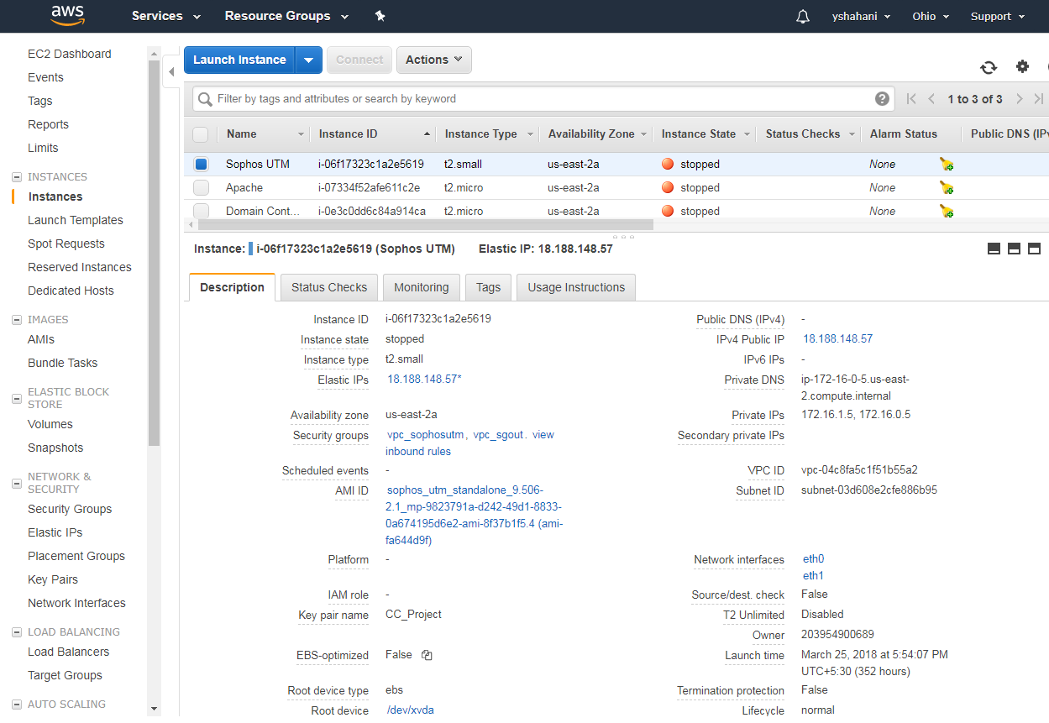

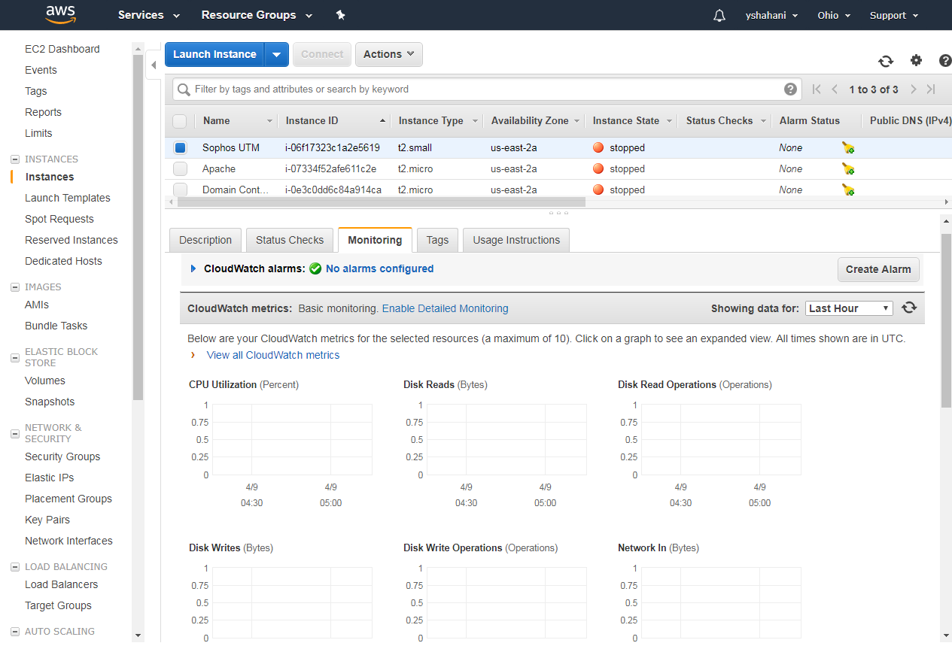

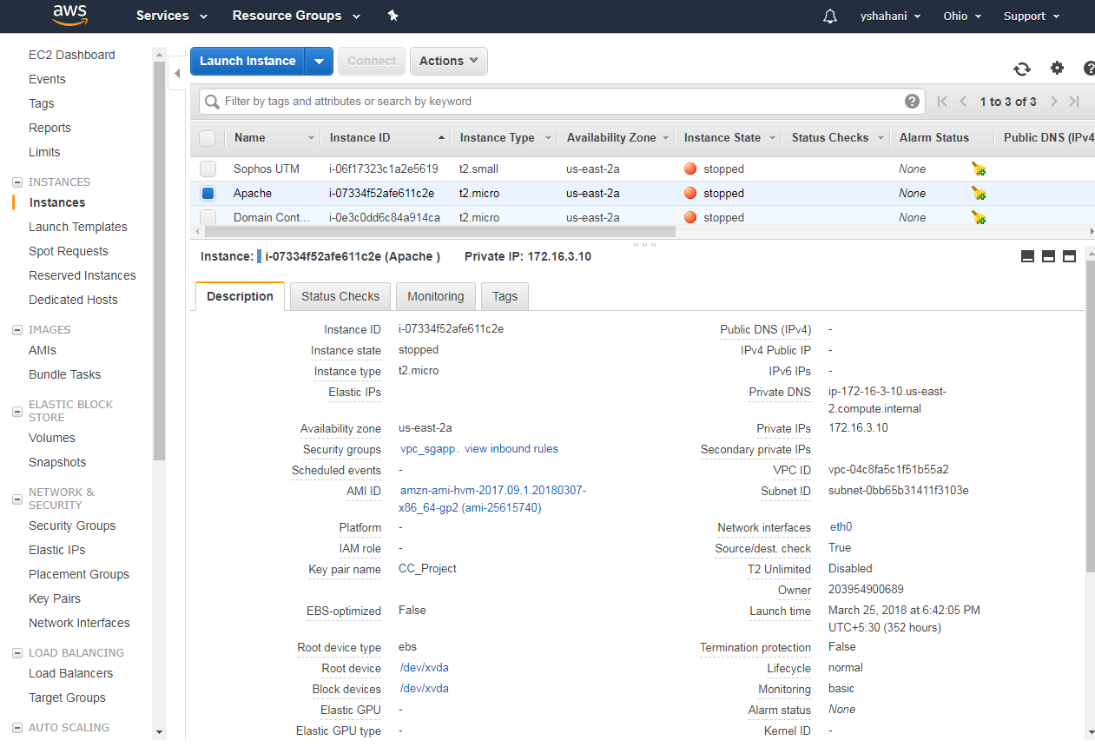

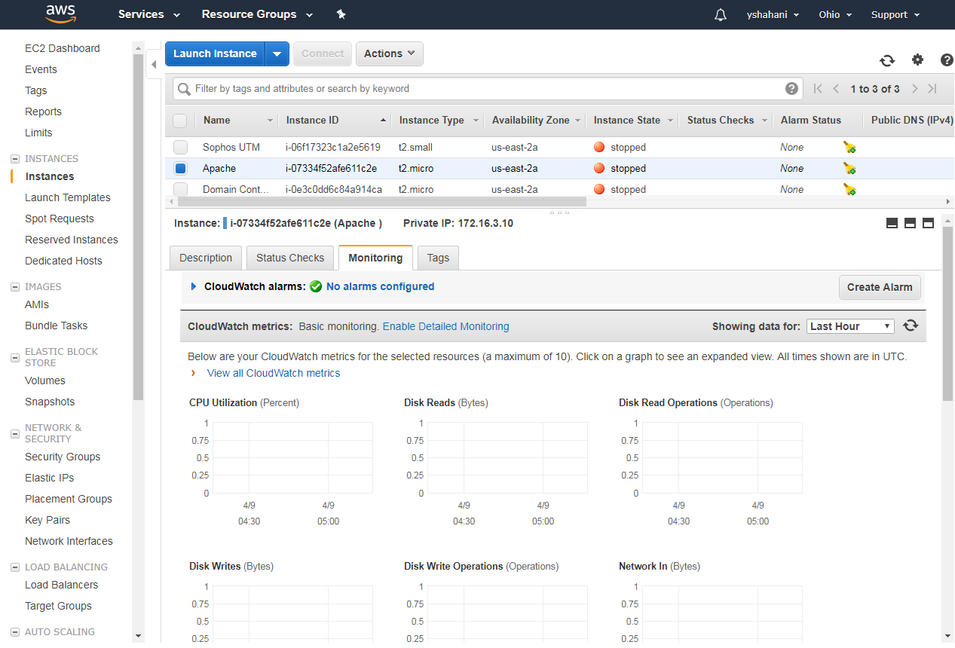

**Security group**

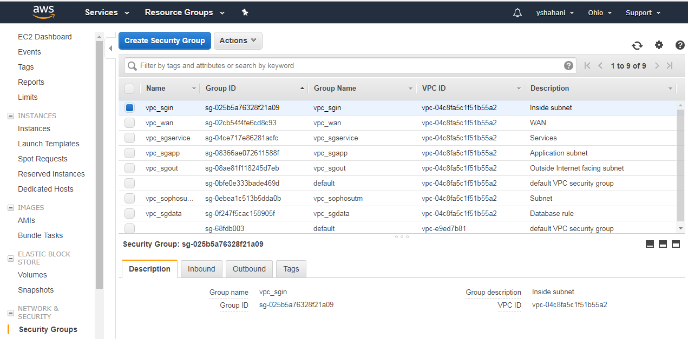

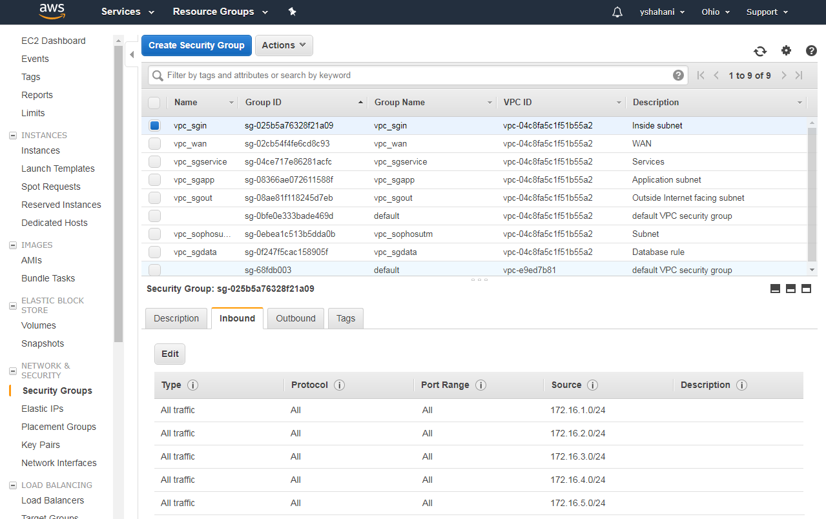

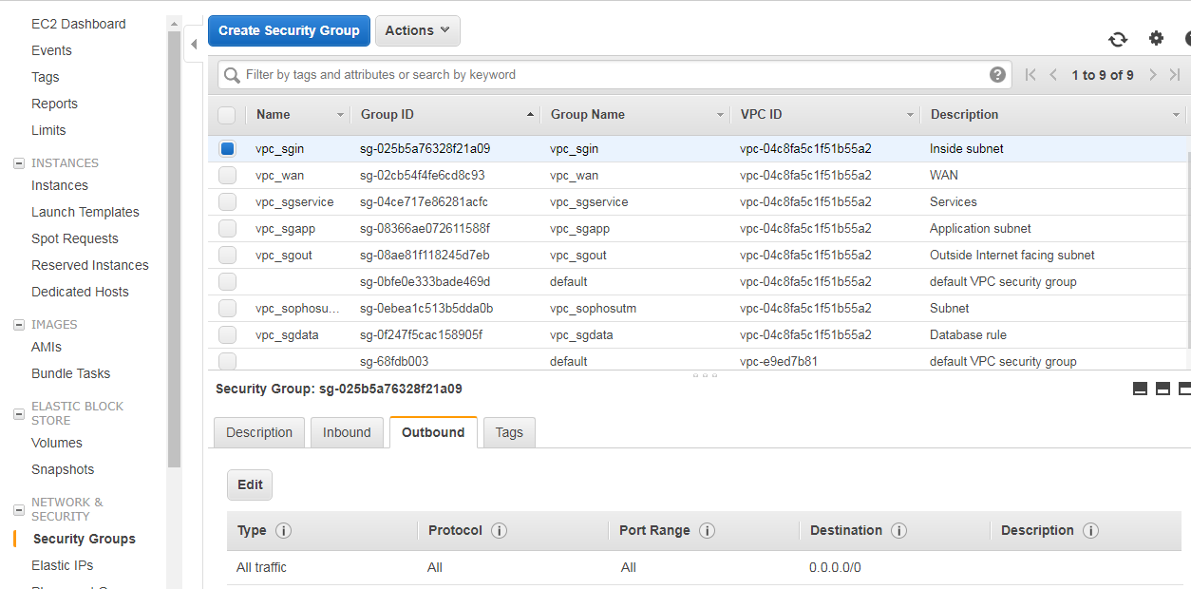

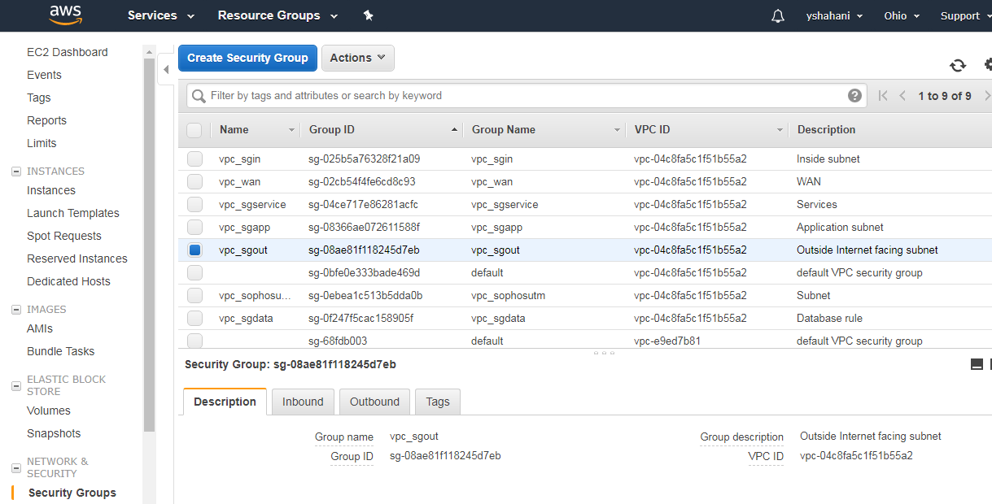

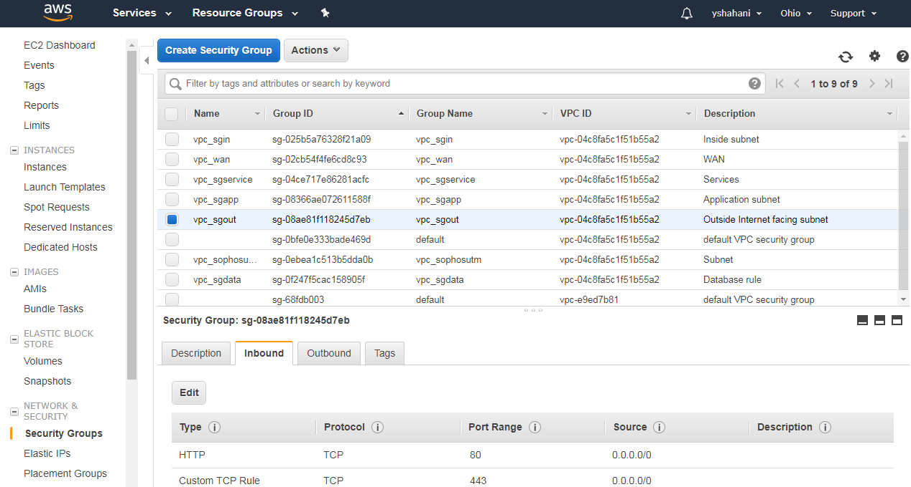

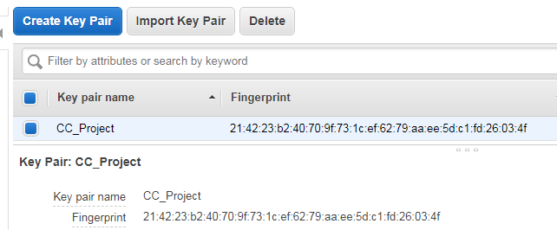

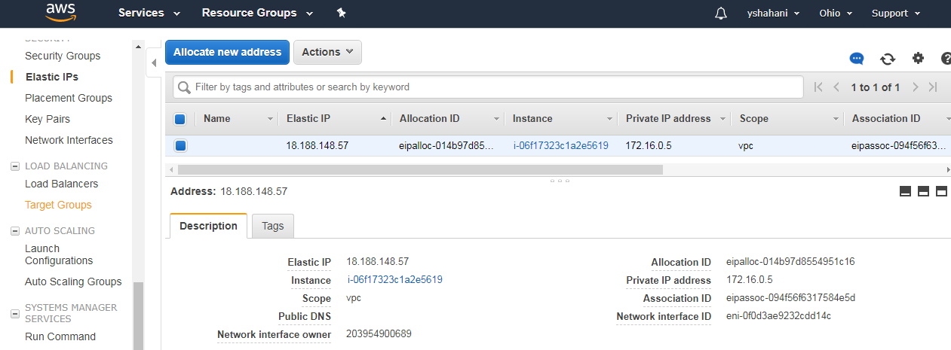

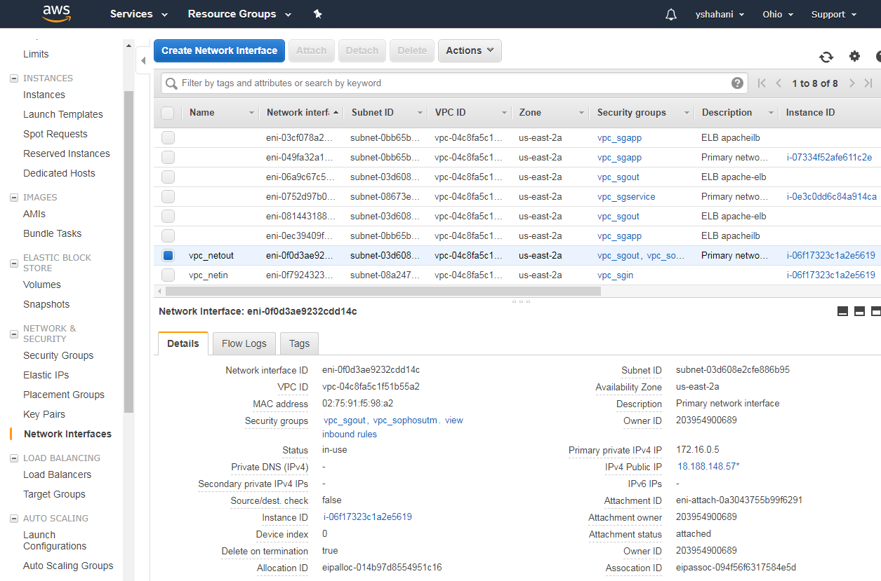

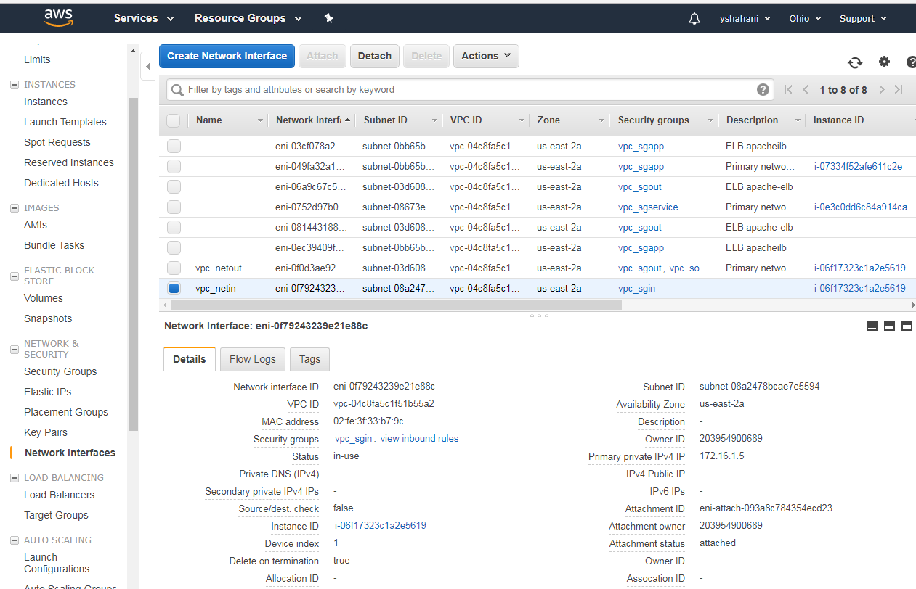

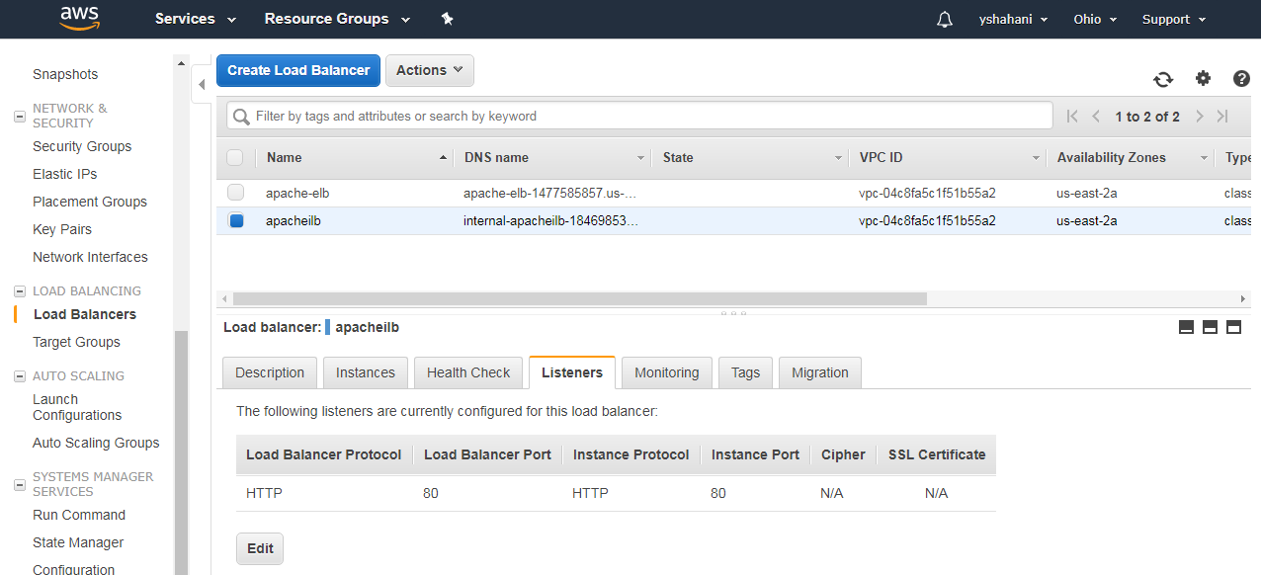

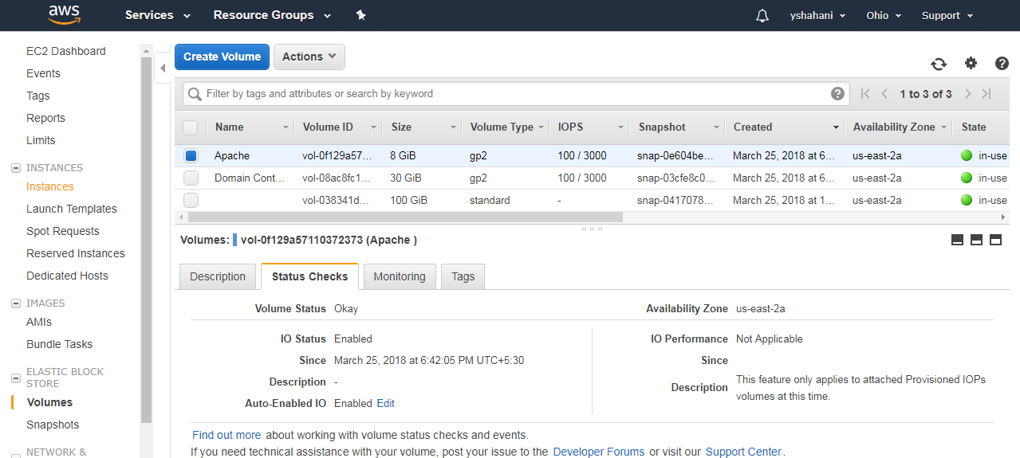

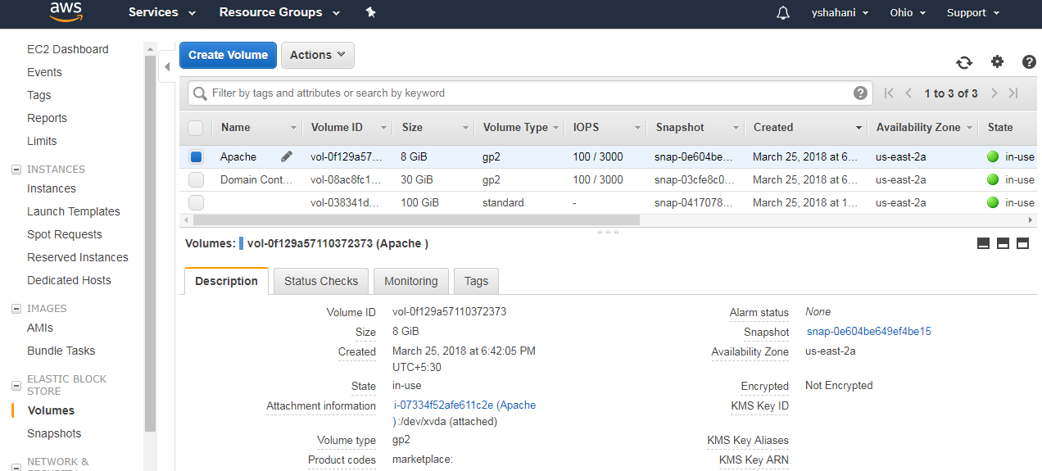

**__________________________________________________________________________________________________________________________________________________________________________________________________________________________________________**

**Sophos UTM:**

